**Graphic Concept**

Art Style

As art style we have chosen stylized/semi-realistic. We chose this because we think it will bring out the beauty of the Greek mythology very well since the creatures of this mythology are quite detailed and we think they will look more impressive. We expect the environment will look better with this art style as well because we use Greece as a reference and the combination of this landscape with the mythological creatures will look better with looking more realistic. We chose to not make it hyper-realistic because we think it will cost us too much time so we chose to make it more stylized.

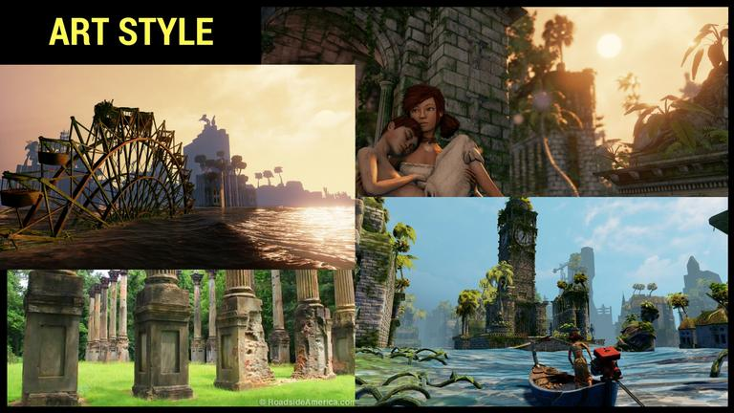

Main Character

Our main character, Theseus, is going to be quite muscular since he is a melee fighter. Since its first person you will mostly see his arms, we are going to give him bracers so the player really gets the feel that he is not just a random person.

Enemies

-Satyr

Our most common enemy will be a Satyr. They will be half human half goat. With legs like a goat, claws for hands and horns. They will stand up straight.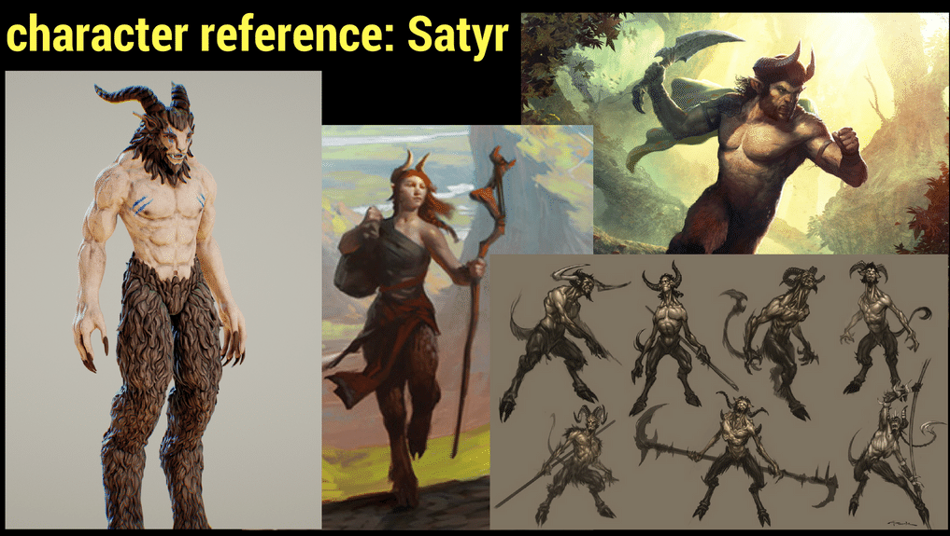

-Minotaur

The Minotaur is our boss enemy. He will be half human half bull. He origins from the Greek mythology. Is very muscular with big horns. He will stand up straight.

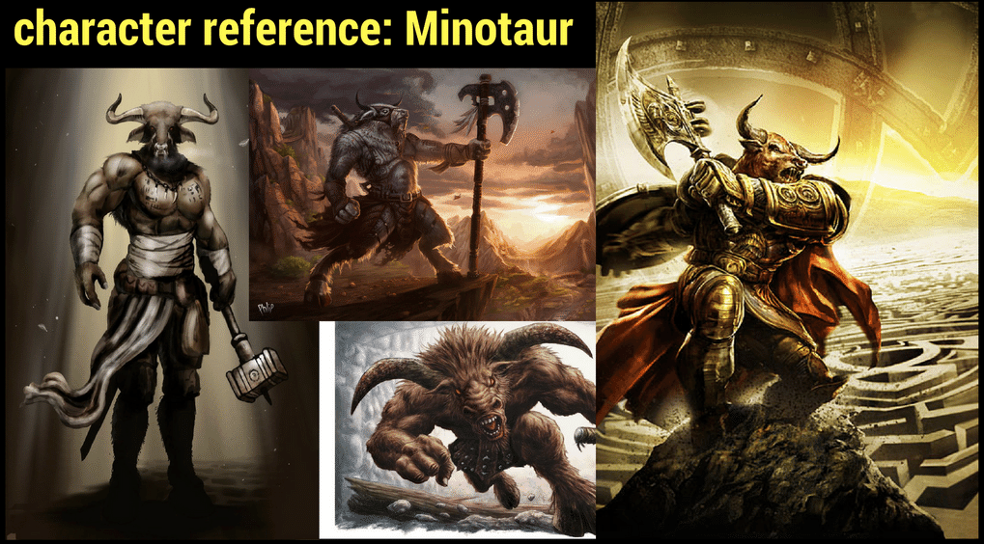

Weapon’s

-Sword

The main character will have a normal Greek sword.

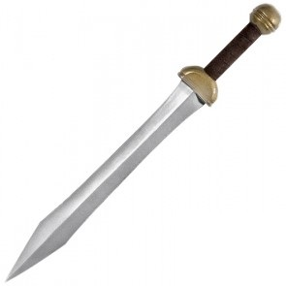

-Trident

Our satyr will wield a trident which is the symbol of Poseidon and the sea.

As the minotaur originates from the white bull of Minos which was a gift to Minos from Poseidon.

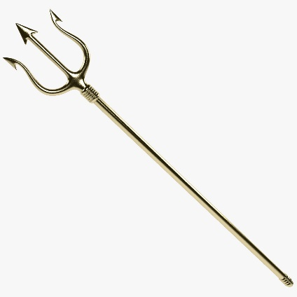

-Double sided axe

For the Minotaur we have a double sided axe because it follows the Greek mythology.

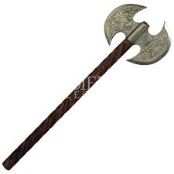

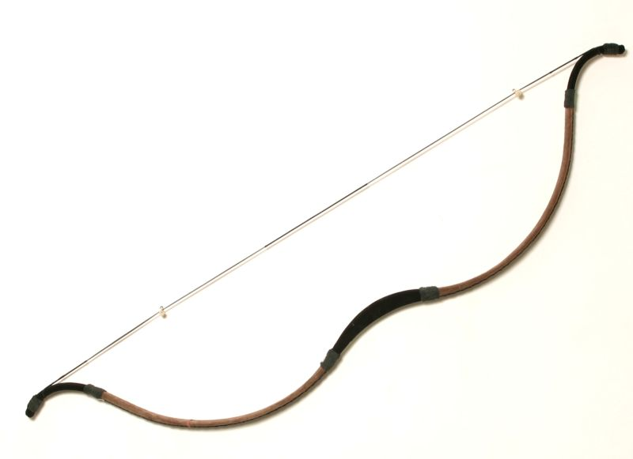-Bow (Optional)

As an optional second class for the Satyr’s we have a bow.

Environment

-Ruins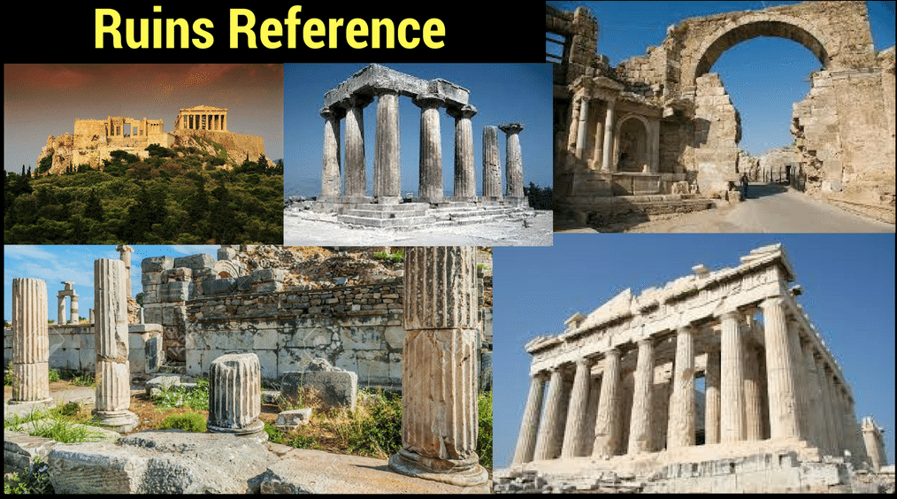

-Labyrinth

In the labyrinth there will be traps to hold you back or kill you.

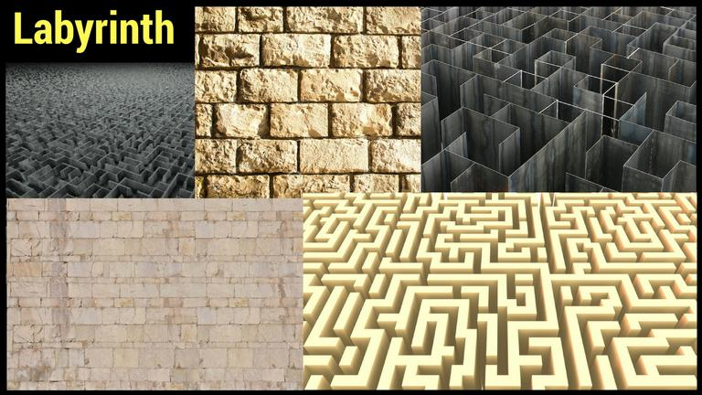

Props

UI Concept

-HUD

A concept of how we want the interface. In the top we have an experience bar. On the right you can see the quests so you can always see what you need to do next. In the bottom left you can see your own health bar. In the bottom you can also see your abilities and such as health regeneration ability.

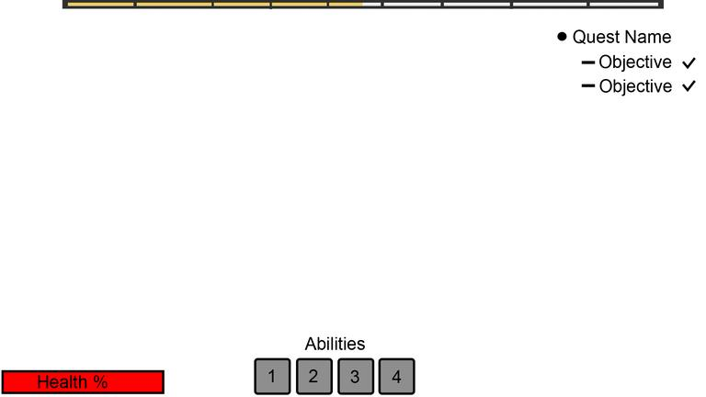

-Enemy health

Satyr

The Satyr’s will get a health bar above their heads. When you look at them you can see how much health they have and you can see if they are almost dead while you are fighting them.

Minotaur

For the Minotaur we want to give the player the option to always be able to see how much health he has since he is our boss. His health bar will pop up in the interface when you walk into the boss room. By doing this the player will always be able to see how much health the minotaur has left even when not facing him.

Resource budget

|  |  |  |
| --- | --- | --- |
| Object | Estimated Time | Poly Amount |
| Character | 2 weeks | 24k |
| Weapon | 2 days | 3-5k |
| Wall & Pillar | 3 days | 300 |
| Ruins |  | 7-10k |
| Props | 2 days | 1-2k |
| Nature | 2 days |  |
| Animation | 3 hours | - |
| Sound | ½ hour | - |
| Particles | 2 hours | - |